
TNFOG SERIES MAGALIR NALAM
TNFOG CME ON “MIDLIFE HEALTH”
Date :22.05.2021 (Saturday) Time :02.30pm to 05.30pm
PROGRAMME
DURATION | TOPIC | SPEAKERS
02.30 – 03.00pm | INAUGURATION
 | WELCOME ADDRESS | Dr.ANJALAKSHI CHANDRASEKAR
 | ADDRESS BY CHIEF GUEST | Dr.P.K.SHAH
 | ADDRESS BY GUEST OF HONOUR | Dr.SUVARNA KHADILKAR
03.00 – 03.40pm | SESSION I  CHAIRPERSONS | Dr.MALA RAJ  Dr.E.S.USHA
03.00 – 03.15pm | MENOPAUSAL SYMPTOMS | Dr.AMBUJA
03.15 – 03.30pm | NUTRITION IN MENOPAUSE | Dr.LAXMI SHRIKHANDE
03.30 – 03.40pm | Q & A
03.40 – 04.40pm | SESSION II  PANEL DISCUSSION ON  “MENOPAUSE CASE SCNARIES”  MODERATOR : Dr.HEPHZIBAH KIRUBAMANI | PANELISTS :  Dr.T.RAMANI DEVI  Dr.N.PALANIAPPAN  Dr.M.CHANDRA PONNUSAMY  Dr.N.SARAVANA KUMAR  Dr.J.AMALA DEVI  Dr.M.G.DHANALAKSHMI
04.40 – 05.20pm | SESSION III  CHAIRPERSONS | Dr.NANCY THANU  Dr.S.RADHA MADHAVI
04.40 – 04.55pm | HORMONAL MANAGEMENT IN MIDLIFE | Dr.PARAG BINIWALE
04.55 – 05.10pm | NONHORMONAL MANAGEMENT IN MIDLIFE | Dr.RAGINI AGARWAL
05.10 – 05.20pm | Q & A
05.20 – 05.30pm | UTI INFECTION | Dr.S.SAMPATH KUMARI
05.30pm | VOTE OF THANKS | Dr.VIJAYALAKSHMI GNANASEKARAN
ACADEMIC PARTNER : TORRENT PHARMA LINK WILL BE SENT SOON

Dr.Anjalakshi Chandrasekar Dr.S.Sampath Kumari
President, TNFOG Hony.Secretary, TNFOG
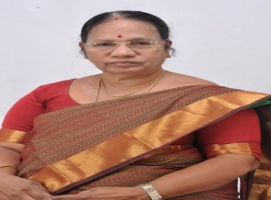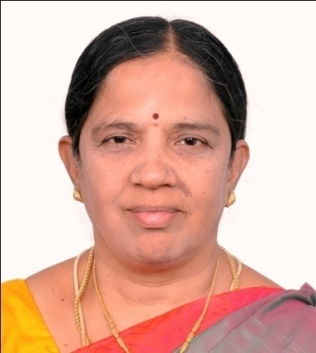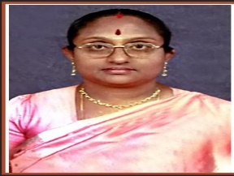

Dr.Anjalakshi Chandrsekar Dr.S.Sampath Kumari Dr.Vijayalakshmi Gnanasekaran
President, TNFOG Secretary, TNFOG Treasurer, TNFOG

CHIEF GUEST GUEST OF HONOUR

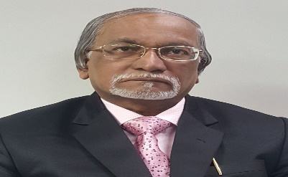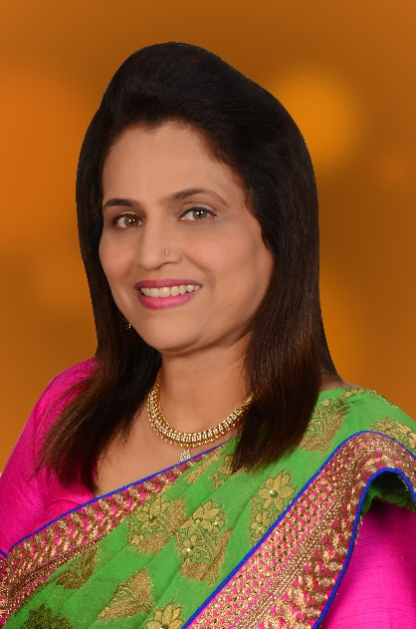

Dr.P.K.SHAH Prof.SUVARNA SATISH KHADILKAR

CHAIRPERSONS

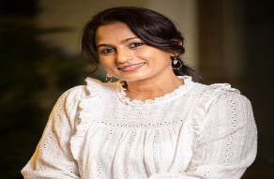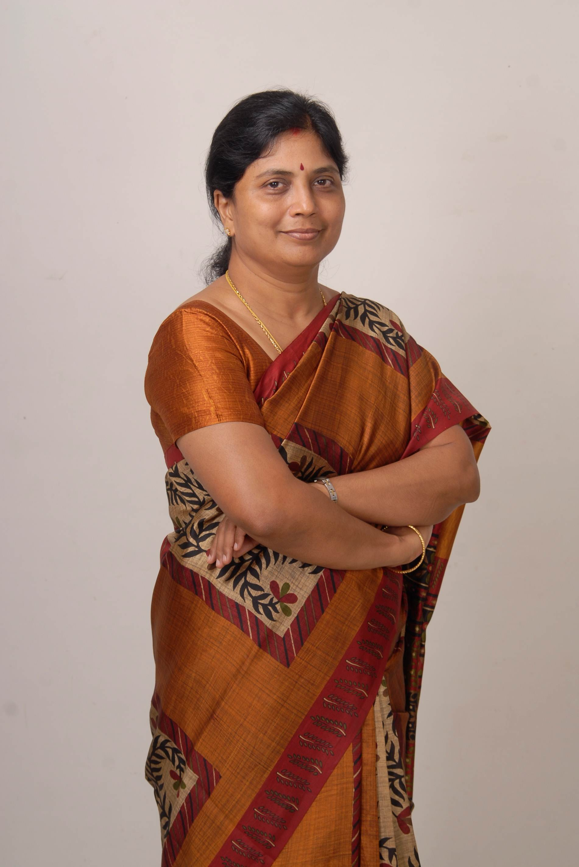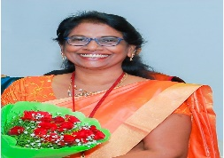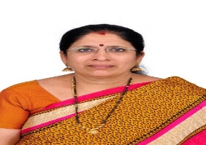

Dr.MALA RAJ Dr.E.S.USHA Dr.NANCY THANU Dr.S.RADHA MADHAVI
MD, Firm Hospital EC Member, Erode Erode OG Society Thiruvannamalai OG Society,

SPEAKERS

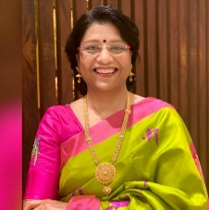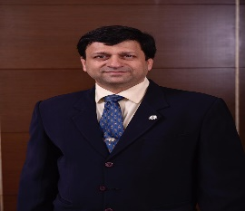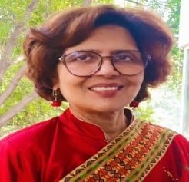
Dr.AMBUJA Dr.LAXMI SHRIKHANDE Dr.PARAG BINIWALE Dr.RAGINI AGARWAL
MD,Shrikhande Fertility Clinic,
Nagpur

MODERATORS PANELISTS

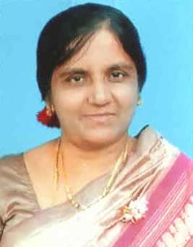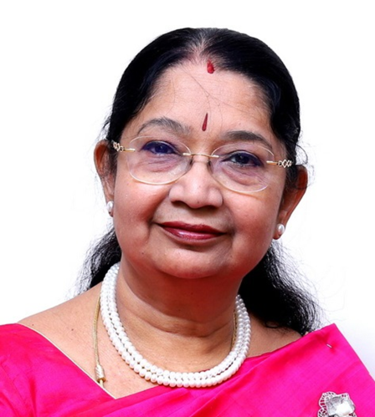
Dr.HEPHZIBAH KIRUBAMANI Dr.T.Ramani Devi
Prof, Saveetha Medical College MD; DGO; FICS; FICOG;
Managing Director

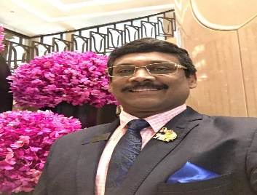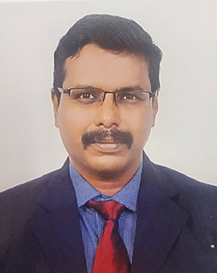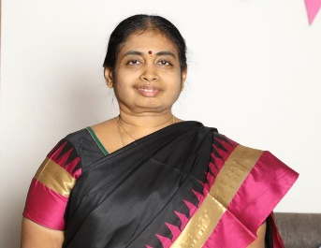

Dr.N.Palaniappan Dr.N.Saravana Kumar Dr.M.Chandra Ponnusamy
EC Member, TNFOG Secretary, OG Society, Salem Chandra Nursing Home, Namakkal

ANCHOR
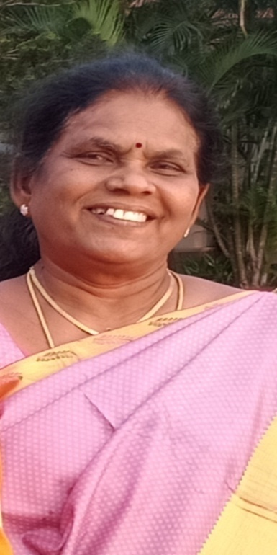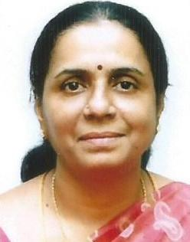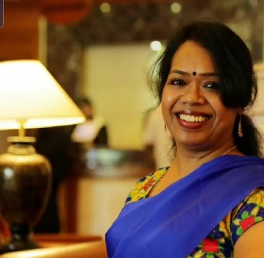
Dr.J.Amala Devi Dr.M.G.Dhanalakshmi Dr.Sumathy Premanand
EC Member, Dindugul Hony.Jt Secretary, OGSSI EC Member, OGSSI

